|  |
| --- |
| **MEASURING THE PULSE OF PROSPERITY : AN INDEX OF ECONOMIC FREEOM ANALYSIS** |
|  |
|  |
|  |

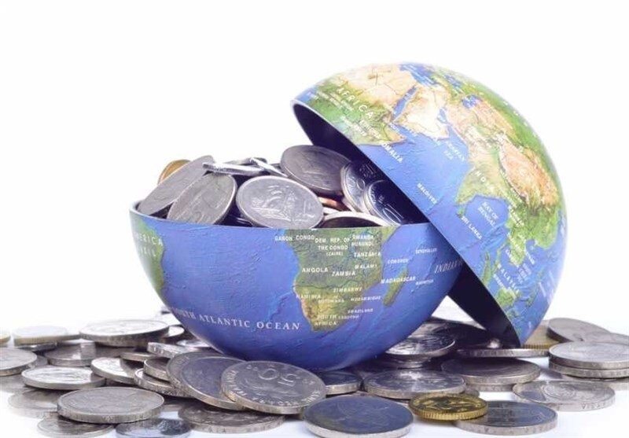

****

|  |  |  |
| --- | --- | --- |
| **CHAPTER NO.** | **CONTENT** | **PAGE NO.** |
| **I** | **INTRODUCTION**   * 1. **OVERVIEW**   2. **PURPOSE** | **3** |
| **II** | **PROBLEM DEFINITION AND DESIGN THINKING**  **2.1 PROBLEM STATEMENT**  **2.2 EMPATHY MAP**  **2.3 BRAISTROMING MAP**  **2.4 BUSINESS REQUIREMENTS**  **2.5 LITERARTURE SURVEY**  **2.6 IMPACTS** | **4** |
| **III** | **DATA COLLECTION AND EXTRACTION FROM DATABASE**  **3.1 SQL**  **3.2 TABLEAU** | **12** |
| **IV** | **ADVANTAGES AND DISADVANTAGES**  **4.1 ADVANTAGES**  **4.2 DISADVANTAGES** | **14** |
| **V** | **APPLICATIONS**  **5.1 APPLICATIONS** | **16** |
| **VI** | **DATA VISUALISATION**  **6.1 TABLEAU VISUALISATION** | **17** |
| **VII** | **CONCLUSION**  **7.1 CONCLUSION**  **7.2 FUTURE ENHANCEMENT** | **22** |
| **VIII** | **APPENDIX**  **8.1 SOURCE CODE** | **24** |

**TABLE OF CONTENT**

**1. INTRODUCTION**

**1.1 OVERVIEW**

Economic freedom is the fundamental right of every human to control his or her own labor and property. In an economically free society, individuals are free to work, produce, consume, and invest in any way they please. In economically free societies, governments allow labor, capital, and goods to move freely, and refrain from coercion or constraint of liberty beyond the extent necessary to protect and maintain liberty itself.

For much of human history, most individuals have lacked economic freedom and opportunity, condemning them to poverty and deprivation.

Today, we live in the most prosperous time in human history. Poverty, sicknesses, and ignorance are receding throughout the world, due in large part to the advance of economic freedom. In 2019, the principles of economic freedom that have fueled this monumental progress are once again measured in the Index of Economic Freedom, an annual guide published by The Heritage Foundation, Washington's No. 1 think tank.

We measure economic freedom based on 12 quantitative and qualitative factors, grouped into four broad categories, or pillars, of economic freedom:

1) Rule of law property rights, government integrity, judicial effectiveness)

2) Government size (government spending, tax burden, fiscal health)

3) Regulatory efficiency (business freedom, labor freedom, monetary freedom)

4) Open markets (trade freedom, investment freedom, financial freedom)

**1.2 PURPOSE**

An index of economic freedom compares the jurisdictions against each other for various aspects, such as trade freedom, judicial effectiveness, and tax burden. These factors may be weighed for their influence on economic freedom and collated into a single score for ranking. The ranking can be assigned based on a country or can contract to smaller sub-national units like states.

**2. PROBLEM DEFINITION AND DESIGN THINKING**

**2.1 PROBLEM STATEMENT**

The above introduction had an aim to increase the awareness about how the economic freedom analysis factors actually has an impact not only on the personal lives of the people, but also an impact on the world and its betterment. We will today have a look on the data extracted from the 2019 economic freedom database from [www.kaggle.com](http://www.kaggle.com), and try to find the insights about how different features have an impact on the economic freedom. The insights drawn cannot be directly used for derivation in the modern world, but it would be surely help us to analyze what role different features play in these analysis.



**2.2 EMPATHY MAP**

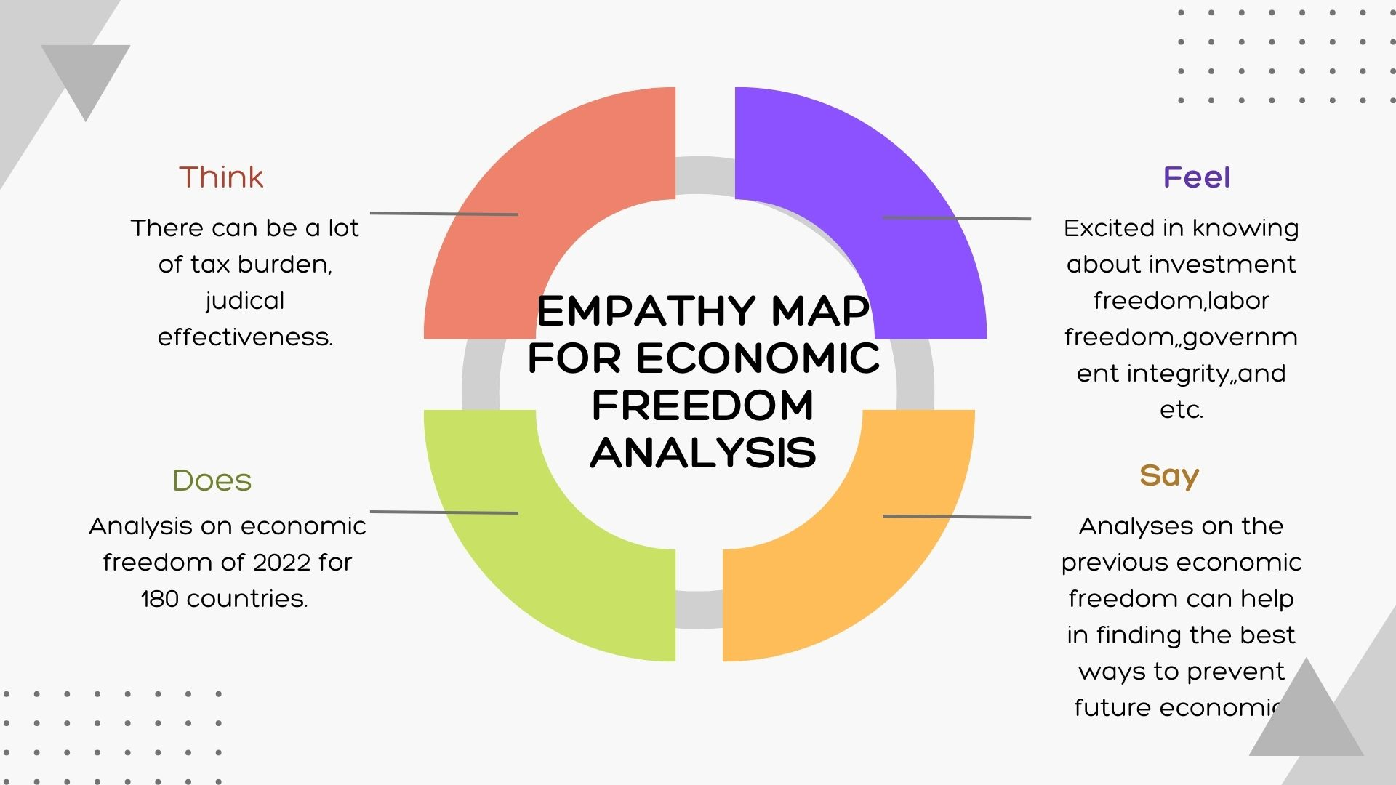

**2.3 BRAINSTORMING MAP**

**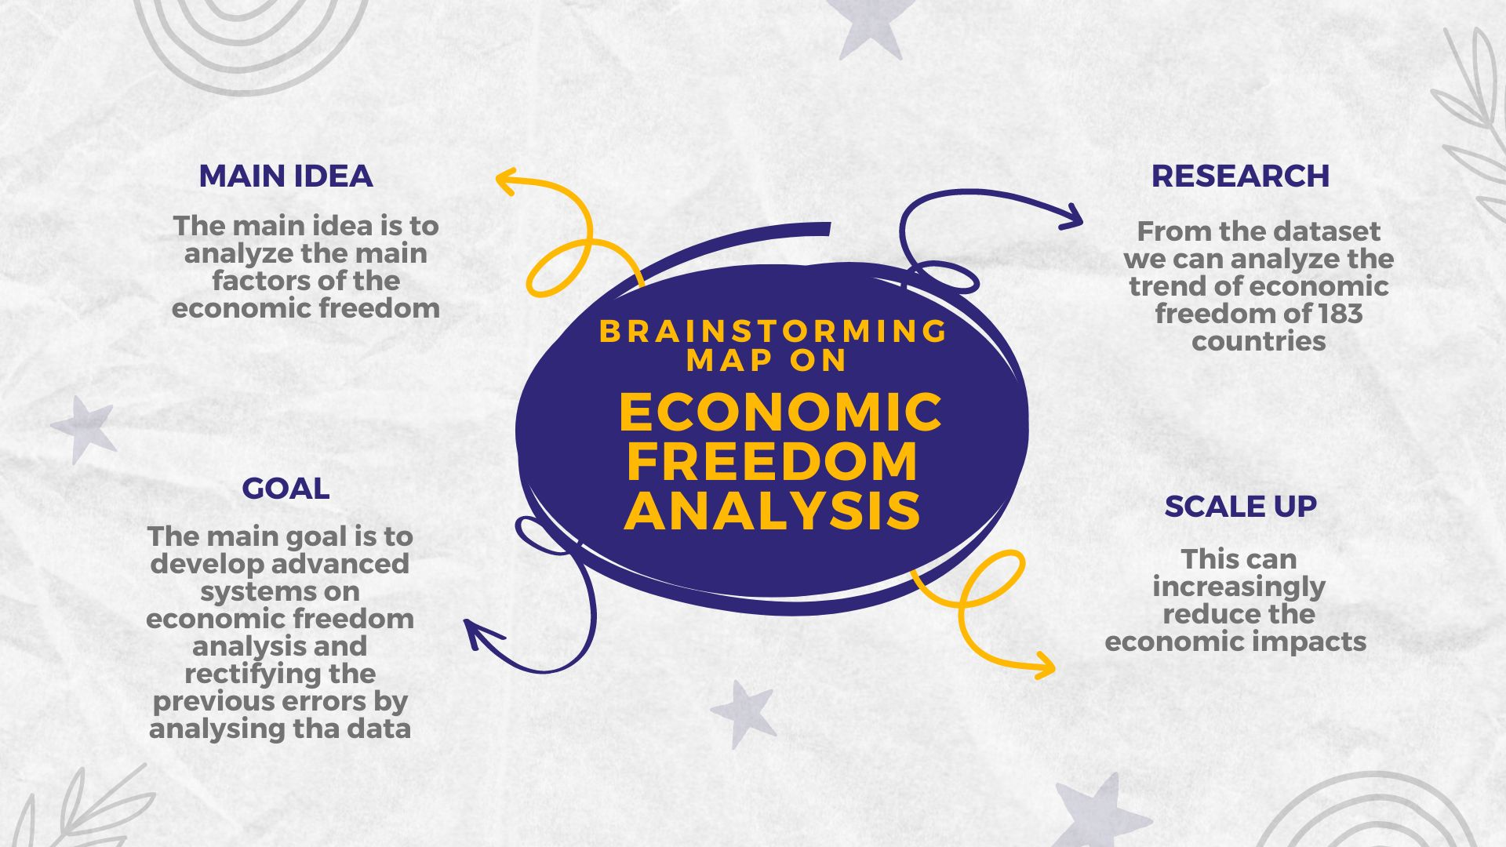**

## 2.4 BUSINESS REQUIREMENTS

## ECONOMIC FREEDOM IS USED FOR INVESTING The Heritage Foundation's Index of Economic Freedom website features a heat map that allows you to view the changes in the world over time. In addition to being academically interesting, the change to economic freedom over time can be a significant data source for investors, particularly those interested in emerging markets.

The index of economic freedom can provide a guide as to whether the potential for hot emerging market picks like the BRIC nations (Brazil, Russia, India, and China) are actually seeing the policy changes necessary for that growth to benefit international investors. On the opposite end, negative changes in the index can be a signal to investors to trim their direct and indirect exposure to nations that are experiencing a decline.

* An index of economic freedom is a composite measure of the quality of political-economic institutions across different jurisdictions.
* Scores and ranks in an index are based on criteria that the creators of the index judge as being relevant, which vary from one index to another.
* These indexes are motivated by the observation that economies that are more free-market based tend to experience greater levels of investment, more rapid growth, and higher average incomes.
* Investors can use the index of economic freedom as a quick way to monitor the changes in economies where they are interested in exposure.
* The Heritage Foundation publishes the most widely-used economic freedom index. However, several institutions publish their own indices.

### POLITICAL FREEDOM DETERMINE ECONOMIC GROWTH

Although there is a correlative relationship between political freedom and economic growth, establishing causation is less certain. One study found that countries that transitioned to a democratic government enjoyed a 20% average gain over 25 years, compared to those that retained authoritarian forms of government.

An MIT economist who co-authored the study suggested that democracies "get rid of special favors" that might inhibit economic growth. They are also more likely to invest in health and human capital, generating long-term economic gains.

### FREE ENTERPRISE SYSTEM LINKED TO ECONOMIC FREEDOM

Economic freedom is a key element of free enterprise, a market-based economic system in which business decisions are made with minimal government interference. Economic freedom, by giving individuals the ability to work, do business, and enter into voluntary contracts with one another, is a key element of the free enterprise system.

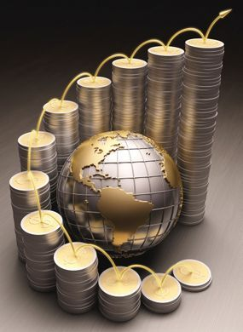

## 2.5 LITERATURE REVIEW

Niclas Berggren’s (2003) article surveys the benefits of economic freedom for economic growth, income equality, quality of life, and human wellbeing. He pointed to several studies; (Gwartney *et al.*, (2002) ,Gwartney, Lawson and Holcombe (1998) , De Haan and Sturm (2000), Adkins, Moomaw and Savvides (2002) , Dawson (1998), Pitlik (2002)). Weede and Kampf (2002) found that the level of economic freedom does not have a positive effect on economic growth, but changes in economic freedom do have such an effect on economic growth. However, other studies by Ali (1997), Easton and Walker (1997), Goldsmith (1997), Dawson (1998)Wu and Davis (1999) ,Hanson (2000) ,and Heckelman (2000) found a positive effect of economic freedom on the growth rate of the economy. Hall and Lawson (2014) conducted an accounting of all the papers citing EWF in the high quality academic journals. The authors state that the Economic Freedom of the World (EFW) index was first produced by Gwartney, Block, and Lawson (1996) and has been updated annually since then. During this period, the EFW index has been cited in hundreds of academic articles. They provide an account and description of this literature. Of 402 articles citing the EFW index, 198 used the index as an independent variable in an empirical study. Over two-thirds of these studies found economic freedom to correspond to a “good” outcome such as faster growth, better living standards, more happiness, *etc.* Less than 4% of the sample found economic freedom to be associated with a “bad” outcome such as increased income inequality. The balance of evidence is overwhelming that economic freedom corresponds with a wide variety of positive outcomes with almost no negative tradeoffs.

De Haanand Sturm (2000) states that economic freedom underlies high levels of economic growth. Their paper compares various indicators for economic freedom and concludes that, although these measures differ somewhat in their coverage, they show similar rankings for the countries covered. Some elements in these measures are, however, questionable. The robustness of the relationship between freedom and growth was also examined and their main conclusion is that greater economic freedom fosters economic growth, but the level of economic freedom is, however, not related to growth. Carlsson and Lundstrom (2002) investigated what specific types of economic freedom measures are important for growth, as most studies of the relationship between economic freedom and growth of GDP have found a positive relationship. One problem in this area they feel is the choice of economic freedom measure. A single measure does not reflect the complex economic environment and a highly aggregated index makes it difficult to draw policy conclusions. They carefully analyzed the robustness of their results since the potential problem with multicolinearity is one of the negative effects of decomposing an index. Their results show that economic freedom does matter for growth. This does not mean that increasing economic freedom, defined in general terms, is good for economic growth since some of the categories in the index are insignificant and some of the significant variables have negative effects.

Scully’s (2002) study investigates the role that economic freedom plays in economic growth and in the distribution in market income, the role of government policy in advancing economic progress and in promoting income equality, and the effect that the rate of economic progress has on the distribution of market income. Structural and reduced form models are estimated and they reveal that economic freedom promotes both economic growth and equity, and there is a positive but relatively small trade-off between growth and income inequality. Hafer (2013) states that a number of studies have found that financial development and higher levels of economic freedom are associated with (cause) economic growth. According to him, the unanswered question is whether the financial development–economic growth nexus reflects influences of economic freedom operating through the financial system. His article closes that loop: it finds that countries with higher levels of initial economic freedom, on average, exhibit greater levels of financial intermediary development in subsequent years. If greater financial intermediary development engenders faster economic growth, the results of this study explain, at least partially, the observed link between economic freedom and economic growth.

Pal, Dutta and Roy’s (2011) study examines the effect of free media on various indicators of socio-political instability. Using a panel of 138 countries during 1994–2005. Their study shows that media free from government control and interference may decrease different forms of socio-political instability because it puts internal and external pressure on self-interested governments to act in the best interests of citizens—rather than their own. Their empirical results suggest that a freer media is associated with lower levels of socio-political instability as measured by ethnic tensions, external and internal conflicts, crime and disorder, military participation in government and religious tensions. The estimates are robust to several sensitivity tests. Williamson and Maters (2011) argues that culture, as measured by the World Values Surveys, and economic institutions associated with economic freedom are both independently important for economic prosperity, but the extent of their impact can be better understood only when both are included in the growth regression. Their results indicate that economic freedom is more important than culture for growth outcomes, suggesting substitutability between the two. They posit that culture is important for growth when economic freedom is absent and diminishes in significance once economic freedom is established

Doucouliagos and Mahmet (2006) in their study apply meta-analytic techniques to the literature on the impact of economic freedom on economic growth and find an overall direct positive association between economic freedom and economic growth. An indirect positive effect of economic freedom on economic growth through the stimulation of physical capital is identified. They state that the literature is affected by specification bias with respect to controls for physical capital. The omission of physical capital results in larger estimates of the economic freedom–economic growth association. They also state that the use of panel data leads to smaller estimates of the impact of economic freedom on economic growth. The meta-analysis is confirmed by primary cross-sectional and panel data analysis of 82 countries for the period 1970–1999.

## REFERENCES

1. “2016 Index of Economic Freedom.” Available online: [**http:/www.heritage.org/index/ranking**](http://www.heritage.org/index/ranking) (accessed on 23 March 2016).
2. N. Berggren. “The Benefits of Economic Freedom: A Survey.” *Indep. Rev.* 8 (2003): 192–211. [[**Google Scholar**](https://scholar.google.com/scholar_lookup?title=The+Benefits+of+Economic+Freedom:+A+Survey&author=N.+Berggren&publication_year=2003&journal=Indep.+Rev.&volume=8&pages=192%E2%80%93211)]
3. J.D. Gwartney, R. Lawson, C. Edwards, W. Park, V. De Rugy, and S. Wagh. *Economic Freedom of the World: 2002 Annual Report*, 6th ed. Vancouver, BC, Canada: Fraser Institute, 2002. [[**Google Scholar**](https://scholar.google.com/scholar_lookup?title=Economic+Freedom+of+the+World:+2002+Annual+Report&author=J.D.+Gwartney&author=R.+Lawson&author=C.+Edwards&author=W.+Park&author=V.+De+Rugy&author=and+S.+Wagh&publication_year=2002)]
4. J.G. Gwartney, R.A. Lawson, and R.G. Holcombe. *The Size and Functions of Government and Economic Growth*. Washington, DC, USA: Joint Economic Committee, 1998, Available online: [**http://frihetspartiet.net/function.pdf**](http://frihetspartiet.net/function.pdf) (accessed on 23 March 2016).
5. J. De Haan, and J. Sturm. “On the relationship between economic freedom and economic growth.” *Eur. J. Polit. Econ.* 16 (2000): 215–241. [[**Google Scholar**](https://scholar.google.com/scholar_lookup?title=On+the+relationship+between+economic+freedom+and+economic+growth&author=J.+De+Haan&author=and+J.+Sturm&publication_year=2000&journal=Eur.+J.+Polit.+Econ.&volume=16&pages=215%E2%80%93241&doi=10.1016/S0176-2680(99)00065-8)] [**[CrossRef](https://dx.doi.org/10.1016/S0176-2680(99)00065-8" \t "_blank)**]
6. L.C. Adkins, R.L. Moomaw, and A. Savvides. “Institutions, Freedom, and Technical Efficiency.” *South. Econ. J.* 69 (2002): 92–108. [[**Google Scholar**](https://scholar.google.com/scholar_lookup?title=Institutions,+Freedom,+and+Technical+Efficiency&author=L.C.+Adkins&author=R.L.+Moomaw&author=and+A.+Savvides&publication_year=2002&journal=South.+Econ.+J.&volume=69&pages=92%E2%80%93108&doi=10.2307/1061558)] [**[CrossRef](https://dx.doi.org/10.2307/1061558" \t "_blank)**]
7. J.W. Dawson. “Institutions, Investment, and Growth: New Cross-Country and Panel Data Evidence.” *Econ. Inq.* 36 (1998): 603–619. [[**Google Scholar**](https://scholar.google.com/scholar_lookup?title=Institutions,+Investment,+and+Growth:+New+Cross-Country+and+Panel+Data+Evidence&author=J.W.+Dawson&publication_year=1998&journal=Econ.+Inq.&volume=36&pages=603%E2%80%93619&doi=10.1111/j.1465-7295.1998.tb01739.x)] [**[CrossRef](https://dx.doi.org/10.1111/j.1465-7295.1998.tb01739.x" \t "_blank)**]
8. H. Pitlik. “The Path of Liberalization and Economic Growth.” *Kyklos* 55 (2002): 57–80. [[**Google Scholar**](https://scholar.google.com/scholar_lookup?title=The+Path+of+Liberalization+and+Economic+Growth&author=H.+Pitlik&publication_year=2002&journal=Kyklos&volume=55&pages=57%E2%80%9380&doi=10.1111/1467-6435.00177)] [**[CrossRef](https://dx.doi.org/10.1111/1467-6435.00177" \t "_blank)**]
9. E. Weede, and S. Kämpf. “The Impact of Intelligence and Institutional Improvements on Economic Growth.” *Kyklos* 55 (2002): 361–380. [[**Google Scholar**](https://scholar.google.com/scholar_lookup?title=The+Impact+of+Intelligence+and+Institutional+Improvements+on+Economic+Growth&author=E.+Weede&author=and+S.+K%C3%A4mpf&publication_year=2002&journal=Kyklos&volume=55&pages=361%E2%80%93380&doi=10.1111/1467-6435.00191)] [**[CrossRef](https://dx.doi.org/10.1111/1467-6435.00191" \t "_blank)**]
10. A. Ali. “Economic Freedom, Democracy, and Growth.” *J. Priv. Enterp.* 13 (1997): 1–20. [[**Google Scholar**](https://scholar.google.com/scholar_lookup?title=Economic+Freedom,+Democracy,+and+Growth&author=A.+Ali&publication_year=1997&journal=J.+Priv.+Enterp.&volume=13&pages=1%E2%80%9320)]

**2.6 IMPACTS**

### Economic impact is a tool to aid policy, program and project decision making by assessing…

* Economic impacts including changes in income and employment
* Fiscal impacts (often termed “value-added”)
* Regional procurement needs
* Workforce planning
* Future community needs due to new and growing population: housing, schools, roads

To provide these assessments, economic impact studies should clearly convey the time period of the study; the economy/region analyzed; as well as the methods, data, and assumptions made to obtain the final dollar and jobs estimates.

****

**3. DATA COLLECTION AND EXTRACTION FROM DATABASE**

**3.1 SQL**

**CREATING SCHEMA:**

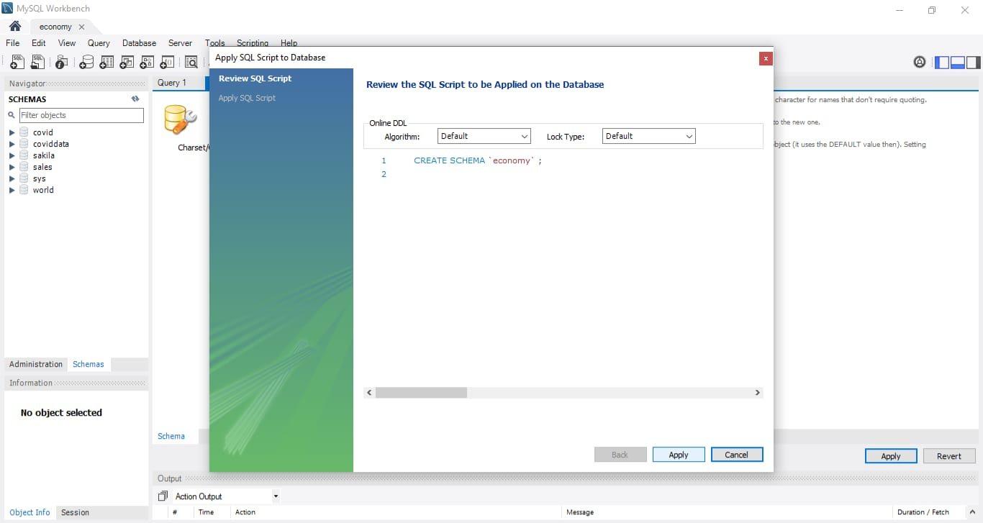

**VIEWING TABLE:**

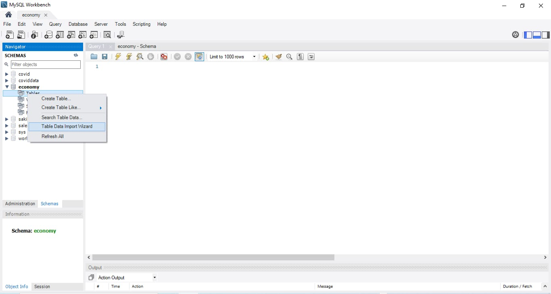

**3.2 TABLEAU**

**INSTALLATION:**

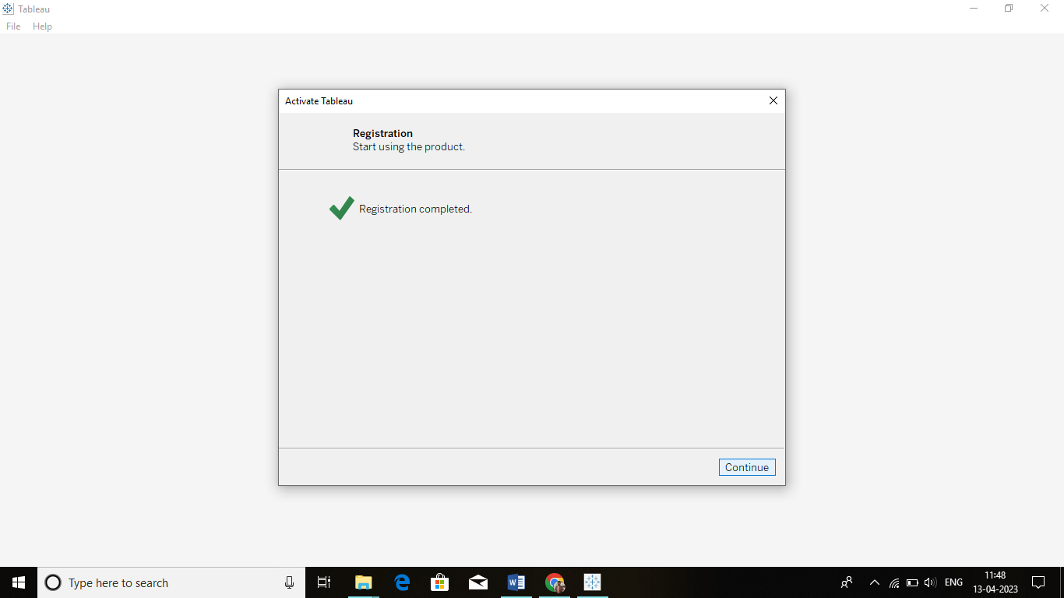

**DEFAULT TABLEAU:**

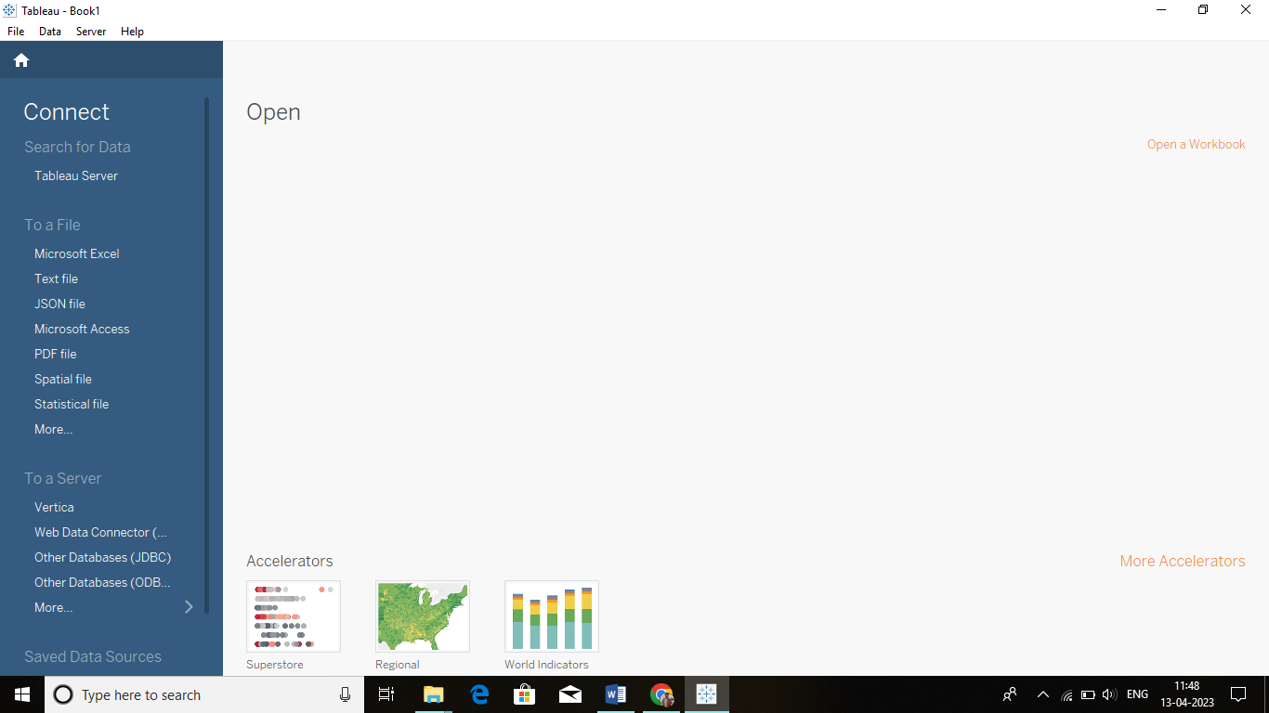

### 4. ADVANTAGES AND DISADVANTAGES

### 4.1 ADVANTAGE OF ECONOMIC FREEDOM ANALYSIS

### HIGHER STANDARD OF LIVING

The biggest advantage of economic growth is that it leads to higher standard of living of the citizens of the country as higher economic growth implies higher per capita income which in turn improves the standard of living of people of the country. In simple words, one cannot expect a higher standard of living without the country having good economic growth as it is one of the factors behind the good standard of living.

### GOOD INFRASTRUCTURE AND TECHNOLOGICAL DEVELOPMENT

Once economic growth happens it leads to increased activity in the economy of the country which in turn gives government good source of income through taxes and other revenues. A government can spend that money on the development of infrastructure of the country by providing good rail, road and air network besides investing money into the power sector, hospitals, and other infrastructure related things. When growth happens it brings with it multinational companies into the country which bring with them latest technologies resulting in technology boom in the country. In simple words, economic growth is the base on which two strong pillars that are infrastructure and technology boom of the nation is dependent.

### JOB OPPORTUNITIES AND EXPOSURE TO WORLD

Another benefit of economic growth is that it brings with it lot of job opportunities as companies need workers if they want to increase the production and hence youth of the nation get jobs and financial security. Besides due to improved technology and multinationals companies coming into the country people get exposure to the world which in future can be of great help if people go outside the country for education, travel or job.

* **HIGHER AVERAGE INCOMES** Economic growth enables consumers to consume more goods and services and enjoy better standards of living. Economic growth during the Twentieth Century was a major factor in reducing absolute levels of poverty and enabling a rise in life expectancy.
* **LOWER UNEMPLOYMENT** With higher output and positive economic growth, firms tend to employ more workers creating more employment.

### 4.2 DISADVANTAGE OF ECONOMIC FREEDOM ANALYSIS

### INFLATION PROBLEM

The biggest disadvantage of economic growth is that it may lead to inflation problem because when the income of the people rises they demand more goods and services and if the economy is unable to provide sufficient goods and services at particular price than it will lead to demand-pull inflation which has its own side effects.

### ENVIRONMENTAL IMPACT

Another limitation is that due to increased industrial activity nation has to face environmental hazards as more pollution means more health problems for the citizens of the country and in the long term it can lead to devastating problem like climate change or global warming problem which in itself is so big problem than it has the potential to negate all the benefits arising from economic growth.

* **WEALTH GAP** An economic growth does not imply that all people of the country will enjoy the fruits of growth rather it creates a big divide between rich and poor because if government does not pay proper attention than due to economic growth rich people will get richer and poor people will get poorer resulting in a wealth gap which we all know has its own problems. Hence in simple words, economic growth along with government policies is one of the reasons behind an increase in wealth gap. As one can see from the pros and cons of economic growth that while economic growth is good for the nation but at the same time if the government does not pay attention to its negative effects that it can also harm the nation. Hence government of the country should ensure that economic growth happens but at the same time, its negative effects should be minimized.

## 5. APPLICATIONS

**5.1 APPLICATION**

## Economic forecasting is the process of attempting to predict the future condition of the economy using a combination of widely followed indicators. Government officials and business managers use economic forecasts to determine fiscal and monetary policies and plan future operating activities, respectively. Since politics is highly partisan, many rational people regard economic forecasts produced by governments with healthy doses of skepticism. The challenges and subjective human behavioral aspects of economic forecasting also lead private-sector economists to regularly get predictions wrong.

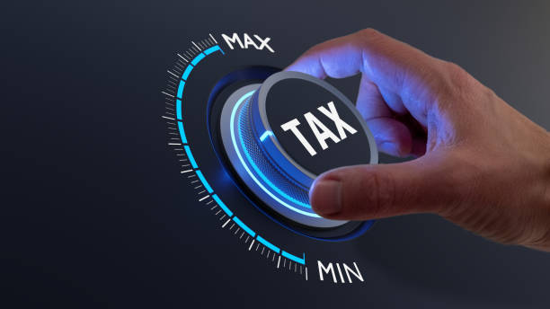

**6. DATA VISUALISATION**

**6.1 TABLEAU VISUALIZATION**

LOADING THE PAGE:

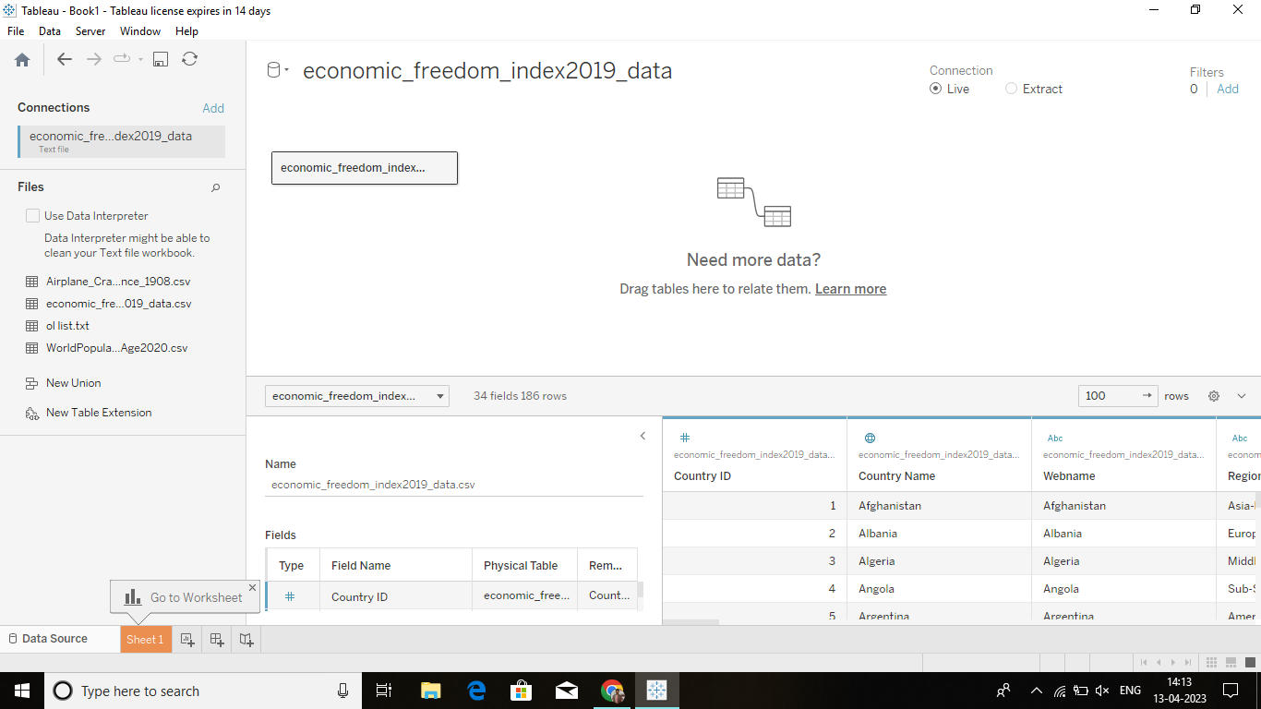

TOP 5 COUNTRIES WITH HIGH INFLATION PERCENTAGE:

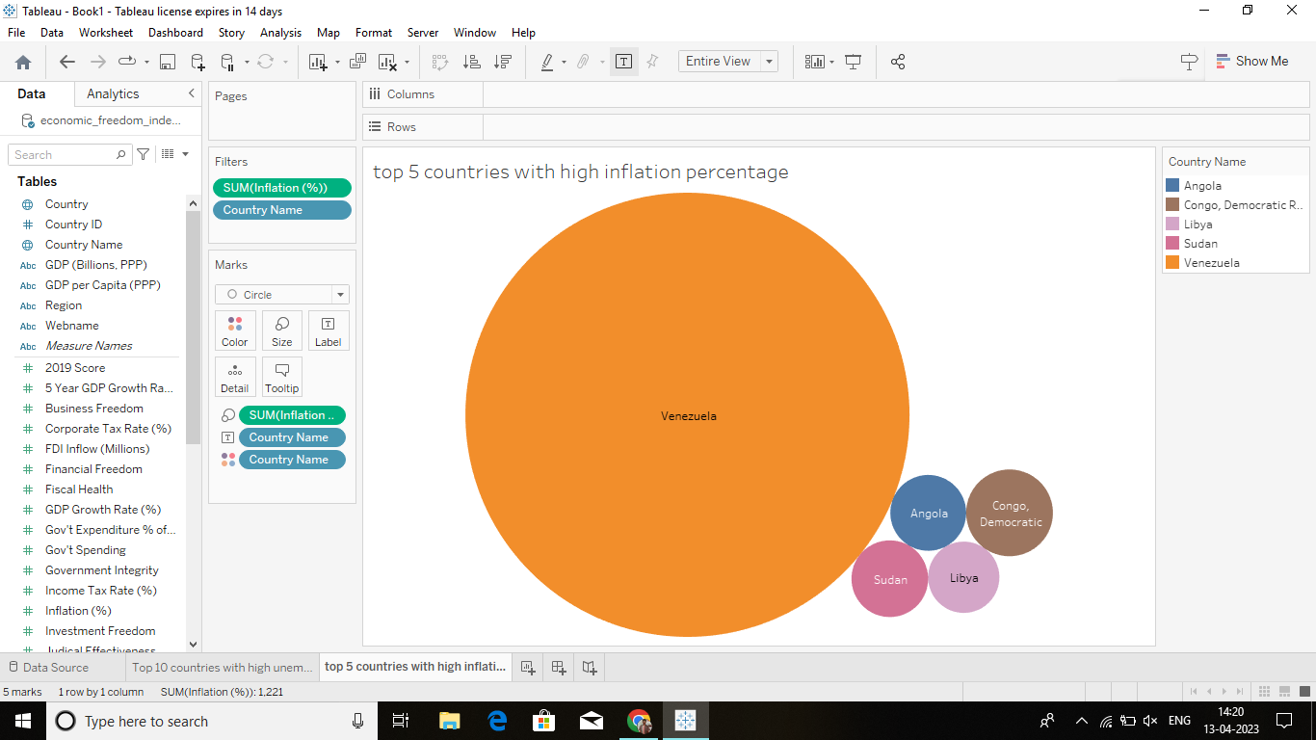

TOP 10 COUNTRIES WITH HIGH UNEMPLOYEMENT:

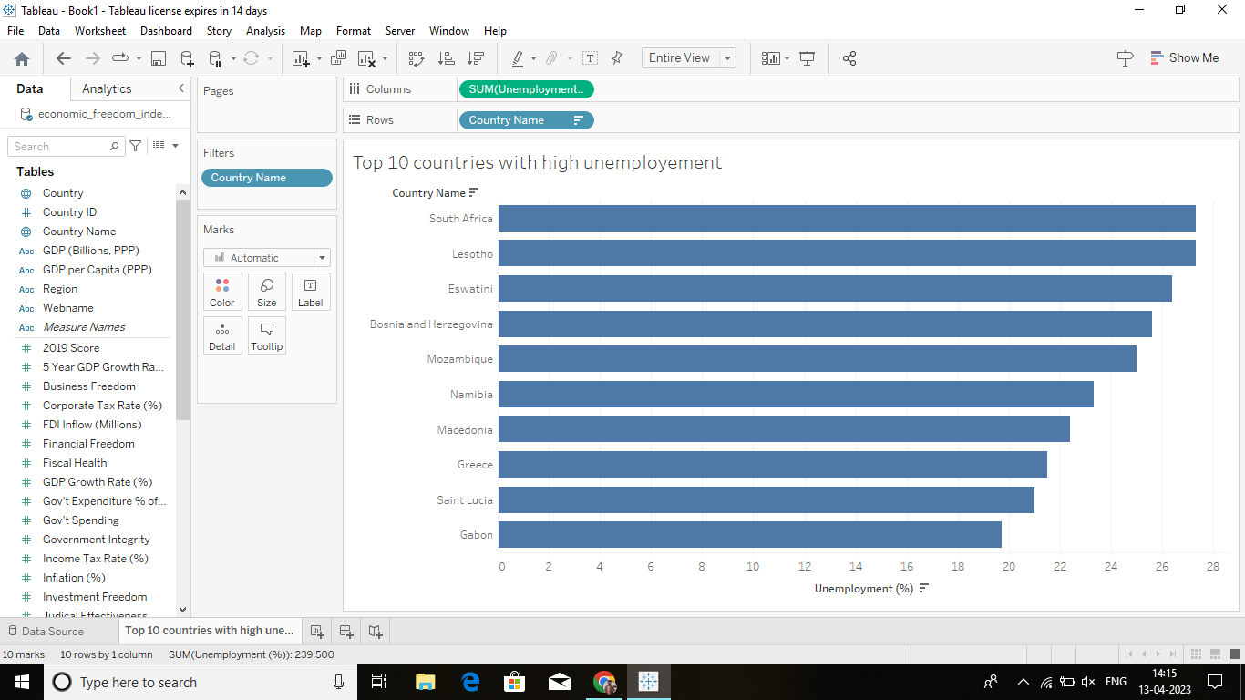

COUNTRIES WITH INCOME TAX RATE AND TARIFF RATE:

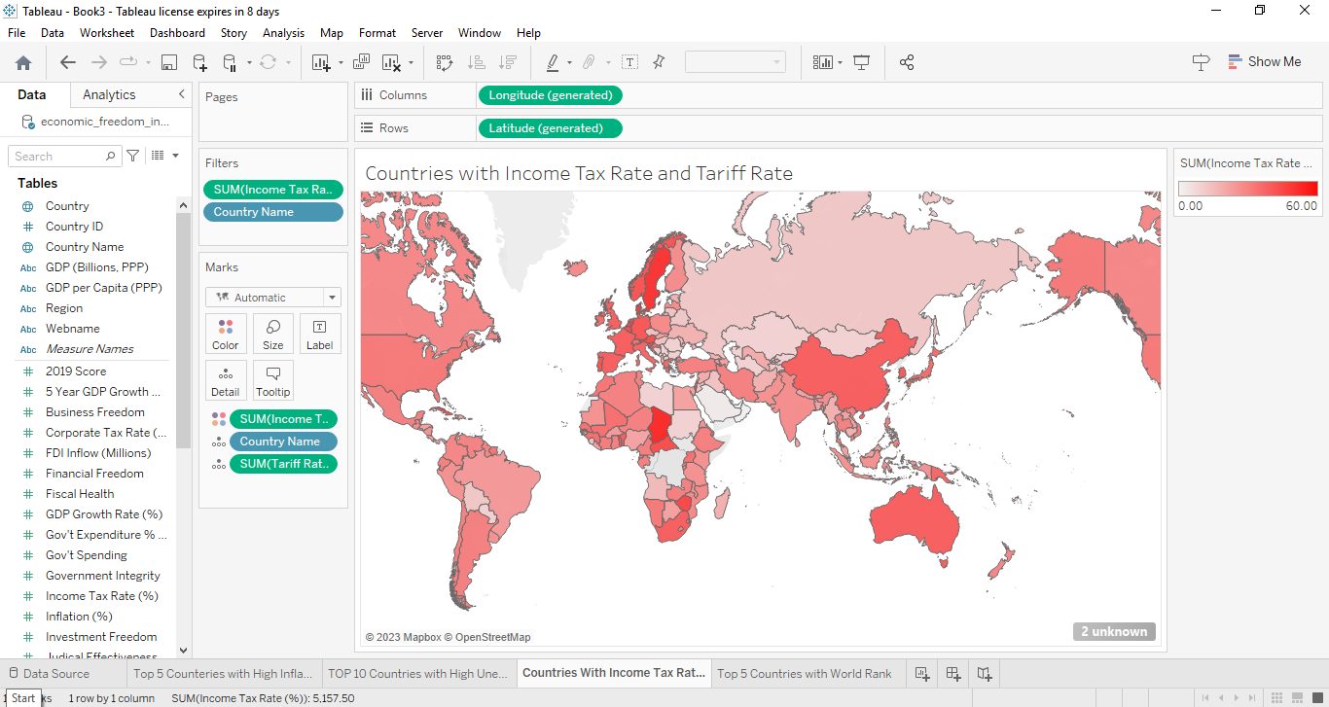

TOP 5 RANKING COUNTRIES IN THE WORLD:

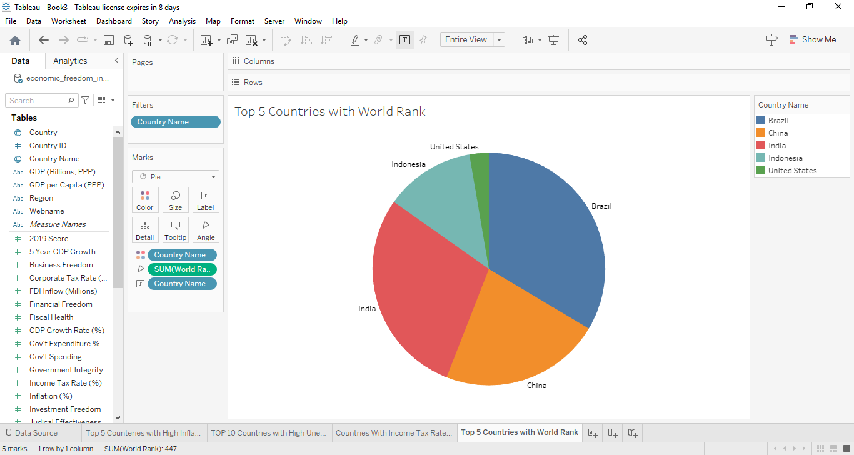

DASHBOARD:

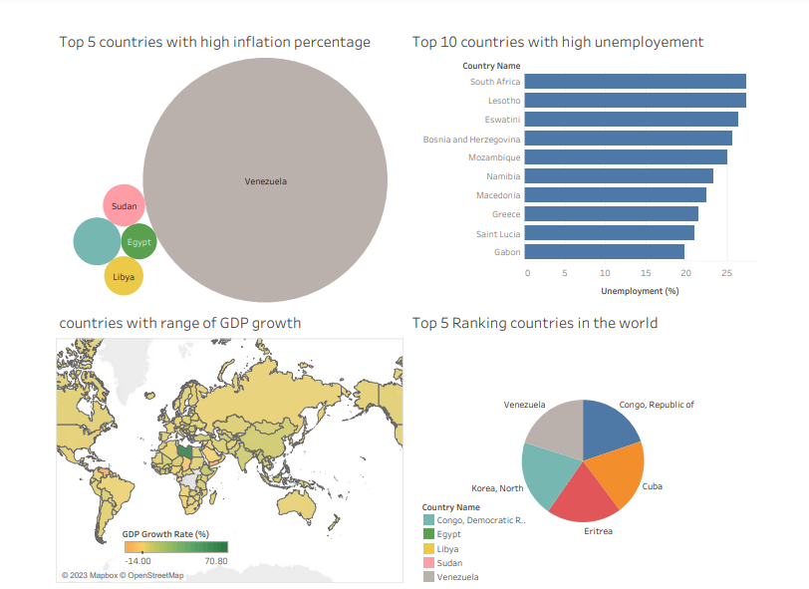

STORY:

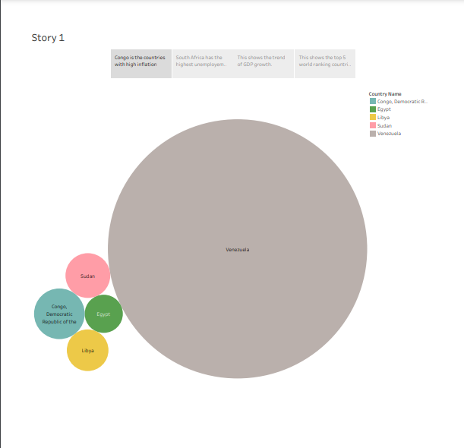

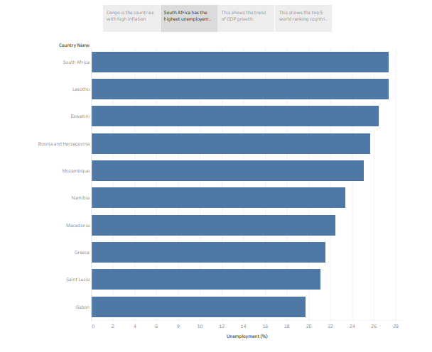

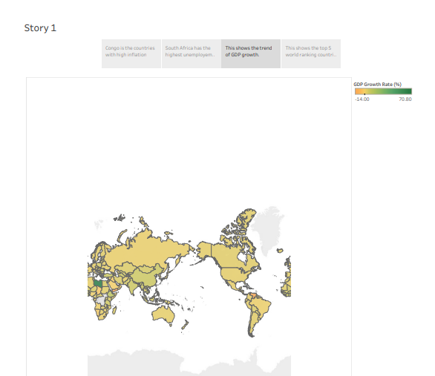

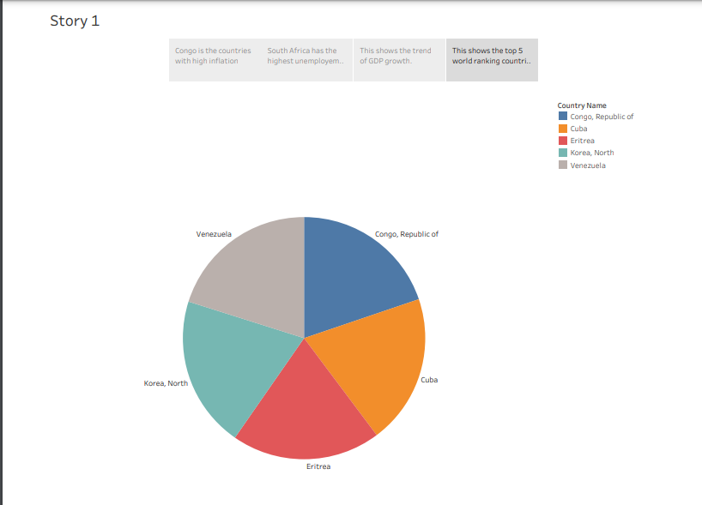

**7. CONCLUSION**

**7.1 CONCLUSION**

## In this study, we investigate the impact of economic freedom on five-year GDP growth rate and annual GDP growth rate and find strong evidence in support of a positive association between the growth rate (measured alternately with annual growth rate and five-year growth rate) and the economic freedom index. The coefficients are of the desired sign (negative for world-rank and positive for score)and they are significant in most of the estimated models. The neo-classical growth models based on production function do not account for one very important determinant of economic growth, namely the economic freedom of a country. Those models only account for labor, capital and technology. Therefore, the external business environment and non-economic factors play an important role in the economic prosperity of any country. Adam Smith had recognised the importance of these factors ahead of time when he pointed out that “ . . . the liberty of individuals to pursue their own economic interests . . . ” For example, corruption, rules and regulations, rule of law, political stability, business friendly environment etc. are crucial determinants of economic growth.

## 7,200+ Economic Freedom Illustrations, Royalty-Free Vector Graphics & Clip Art - iStock | Time, Market, Indiana

**7.2 FUTURE ENHANCEMENT**

Economics predicts what will happen in the future regarding wants and resources. An important part of convincing people to trust your expert opinion is successfully predicting what will happen. For example, if economists suggest that there will be an economic boost if the government exports more and imports less, this is a successful prediction. It's not magic; it results from describing, analyzing, and explaining economic activity! Prediction helps us make informed decisions.

**8. APPENDIX**

**SOURCE CODE:**

* **DATASET:**

[**https://drive.google.com/file/d/10xHwLzOYeRW\_GweNOE2sCgzAwi5z9Zy/view?usp=share\_link**](https://drive.google.com/file/d/10xHwLzOYeRW_GweNOE2sCgzAwi5z9Zy/view?usp=share_link)

* **EMPATHY MAP:**

[**https://drive.google.com/file/d/1S60RdYhzm2RbwGLg06s9do5TEeOXkjFJ/view?usp=drivesdk**](https://drive.google.com/file/d/1S60RdYhzm2RbwGLg06s9do5TEeOXkjFJ/view?usp=drivesdk)

* **BRAINSTORMING MAP :**

[**https://drive.google.com/file/d/1S5D6pJPQp6BvXmiT08DqfmxCxasdYoX/view?usp=drivesdk**](https://drive.google.com/file/d/1S5D6pJPQp6BvXmiT08DqfmxCxasdYoX/view?usp=drivesdk)

* **TABLEAU WORKBOOK :**

[**https://drive.google.com/file/d/1OPWPe9OJQMXaykGiBxveSxcvAKeZXo1U/view?usp=share\_link**](https://drive.google.com/file/d/1OPWPe9OJQMXaykGiBxveSxcvAKeZXo1U/view?usp=share_link)

* **TABLEAU WORKBOOK VIDEO:**

## [https://drive.google.com/file/d/1GyxCw1sRMBdcksnRIVuVUqOyowfYHiTy/view?u sp=sharing](https://drive.google.com/file/d/1GyxCw1sRMBdcksnRIVuVUqOyowfYHiTy/view?u sp=sharing)

## Thank you - flowers decoration , floral background and beautiful handwriting Stock Photo by ©hanohiki 77078571